Q1 | Create a SQL table called Restaurant with columns: id, name, cuisine, location, and average_rating. Insert at least 5 sample rows representing popular restaurants from Zomato.
Code | Create table restaurants:  CREATE TABLE Restaurant ( id INT AUTO_INCREMENT, name VARCHAR(100), cuisine VARCHAR(50), location VARCHAR(100), average_rating DECIMAL(2,1), PRIMARY KEY(id) );  Insert record:  INSERT INTO Restaurant (name, cuisine, location, average_rating) VALUES ('Barbeque Nation', 'North Indian', 'Ahmedabad', 4.5), ('Dominos Pizza', 'Italian', 'Surat', 4.2), ('The Grand Thakar', 'Gujarati', 'Ahmedabad', 4.7), ('Mainland China', 'Chinese', 'Vadodara', 4.4), ('Udupi Restaurant', 'South Indian', 'Rajkot', 4.3), ('Honest', 'North Indian', 'Surat', 4.4), ('Pizza Hut', 'Italian', 'Ahmedabad', 4.3), ('Gwalia Sweets', 'Gujarati', 'Rajkot', 4.2), ('Sankalp', 'South Indian', 'Ahmedabad', 4.6), ('Spice Villa', 'Chinese', 'Surat', 4.1);  Show table:  SELECT * from restaurant;
Output | 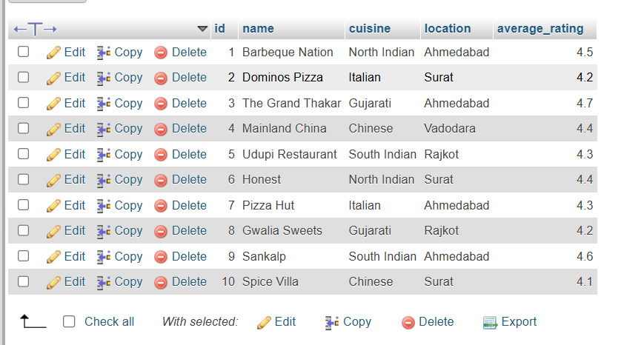

Q2 | Write a SQL query to generate a report showing the number of restaurants for each cuisine type from your Restaurant table, ordered by the count in descending order.<br><br><em><strong>Hint:</strong> Use GROUP BY and ORDER BY.</em>
Code | SELECT cuisine, COUNT(id) AS restaurant_count FROM Restaurant GROUP BY cuisine ORDER BY restaurant_count DESC;
Output | 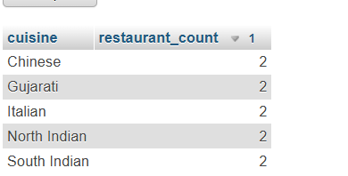

Q3 | Add a new table called Review with columns: id, restaurant_id, user_name, rating, and review_date. Insert at least 10 sample reviews, linking them to restaurants using restaurant_id.
Code | Create table restaurants:  CREATE TABLE Restaurant ( id INT AUTO_INCREMENT, name VARCHAR(100), cuisine VARCHAR(50), location VARCHAR(100), average_rating DECIMAL(2,1), PRIMARY KEY(id) );  Insert record:  INSERT INTO Restaurant (name, cuisine, location, average_rating) VALUES ('Barbeque Nation', 'North Indian', 'Ahmedabad', 4.5), ('Dominos Pizza', 'Italian', 'Surat', 4.2), ('The Grand Thakar', 'Gujarati', 'Ahmedabad', 4.7), ('Mainland China', 'Chinese', 'Vadodara', 4.4), ('Udupi Restaurant', 'South Indian', 'Rajkot', 4.3), ('Honest', 'North Indian', 'Surat', 4.4), ('Pizza Hut', 'Italian', 'Ahmedabad', 4.3), ('Gwalia Sweets', 'Gujarati', 'Rajkot', 4.2), ('Sankalp', 'South Indian', 'Ahmedabad', 4.6), ('Spice Villa', 'Chinese', 'Surat', 4.1);  Show table:  SELECT * from restaurant;  Create second table review:  CREATE TABLE Review ( id INT PRIMARY KEY, restaurant_id INT, user_name VARCHAR(100), rating DECIMAL(2,1), review_date DATE, FOREIGN KEY (restaurant_id) REFERENCES Restaurant(id) );  Insert record:  INSERT INTO Review (id, restaurant_id, user_name, rating, review_date) VALUES (1, 1, 'Mayank', 4.5, '2026-07-01'), (2, 1, 'Rahul', 4.0, '2026-07-02'), (3, 2, 'Priya', 4.2, '2026-07-03'), (4, 2, 'Dipti', 4.5, '2026-07-04'), (5, 3, 'Aman', 4.8, '2026-07-05'), (6, 3, 'Neha', 4.6, '2026-07-06'), (7, 4, 'Karan', 4.1, '2026-07-07'), (8, 4, 'Riya', 4.3, '2026-07-08'), (9, 5, 'Yarta', 4.4, '2026-07-09'), (10, 5, 'Priyanshu', 4.7, '2026-07-10');  Show table:  SELECT * FROM review;
Output |   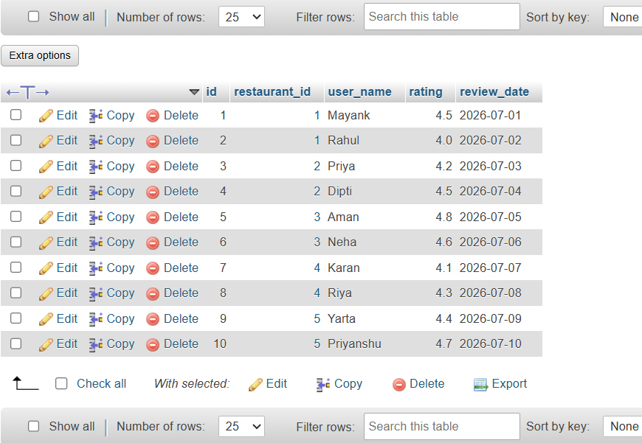

Q4 | Write a SQL query using a JOIN to display each restaurant's name, cuisine, and its average review rating (from the Review table), ordered by highest average rating first.<br><br><em><strong>Hint:</strong> Use JOIN and GROUP BY with aggregate functions.</em>
Code | SELECT r.name, r.cuisine, AVG(rv.rating) AS average_review_rating FROM Restaurant r JOIN Review rv ON r.id = rv.restaurant_id GROUP BY r.id, r.name, r.cuisine ORDER BY average_review_rating DESC;
Output | 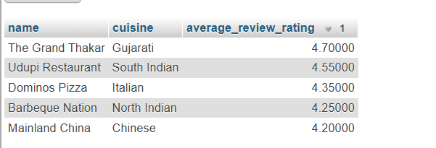

Q5 | Use a window function to rank restaurants by their average review rating within each cuisine type, showing the restaurant name, cuisine, average rating, and rank.<br><br><em><strong>Hint:</strong> Use the RANK() or DENSE_RANK() window function partitioned by cuisine.</em>
Code | By rank()  SELECT name, cuisine, average_rating, RANK() OVER ( PARTITION BY cuisine ORDER BY average_rating DESC ) AS restaurant_rank FROM ( SELECT r.name, r.cuisine, AVG(rv.rating) AS average_rating FROM Restaurant r JOIN Review rv ON r.id = rv.restaurant_id GROUP BY r.id, r.name, r.cuisine ) AS RestaurantRatings;  By DENSE_RANK()  SELECT name, cuisine, average_rating, DENSE_RANK() OVER ( PARTITION BY cuisine ORDER BY average_rating DESC ) AS restaurant_rank FROM ( SELECT r.name, r.cuisine, AVG(rv.rating) AS average_rating FROM Restaurant r JOIN Review rv ON r.id = rv.restaurant_id GROUP BY r.id, r.name, r.cuisine ) AS RestaurantRatings;
Output | 